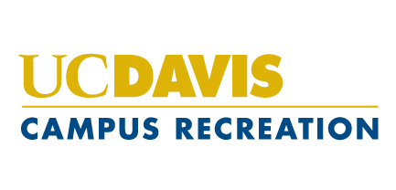
Position Announcement 2022-2023

Competitive Sports Recorder Manager

General Description:
Under the direct supervision of the Sport Clubs Coordinator, Rec Sports Coordinator, Competitive Sports Coordinators, Competitive Sports Assistant Director and the Associate Director. The Competitive Sports Recorder Manager is responsible for basic Recorder duties in addition to the following:

- Serve as the representative of the Competitive Sports program in Rec and Sport Clubs Office
- Serve as the liaison between Recorders and the Competitive Sports professional staff
- Enforce all Competitive Sports and University Policies and Procedures
- Provide professional customer service
- Conflict management and problem solving
- Supervise, direct, and evaluate Recorders
- Make schedules as needed
- Create, schedule, and run recorder meetings
- Delegate Fleet
- Send form templates and reminder emails
- Interview, hire, and train new recorders
- Keep track of late forms
- Updating manuals and forms as needed
- Inventory of supplies
- Access and operate SAMBA Safety, Fusion, and Do Sports Easy
- Approve Sport Club travel events and insurance paperwork
- Manage assigned Sport Clubs home events
- Manage Club Finances
- Other duties as assigned
- Manage several Sport Clubs by helping them plan events and organize paperwork

Qualifications:
- Sport Club knowledge
- Available to work a 10-15 hours/week; attend weekly meetings with Sport Clubs and Competitive Sports Coordinator
- Excellent oral and written communication skills
- Integrity and Honesty
- Good Judgment
- Professionalism
- Awareness of and appreciation for individual uniqueness and diversity
- Ability to work independently and make critical decisions
- Must be available for Competitive Sports Staff Training in mid-September

Pay:
Currently at $17.50 per hour

How to Apply:
Submit a resume and cover letter to Recorder Managers: screcordermanager@gmail.com by 5 p.m. on March 14. Interview dates will be TBD.

