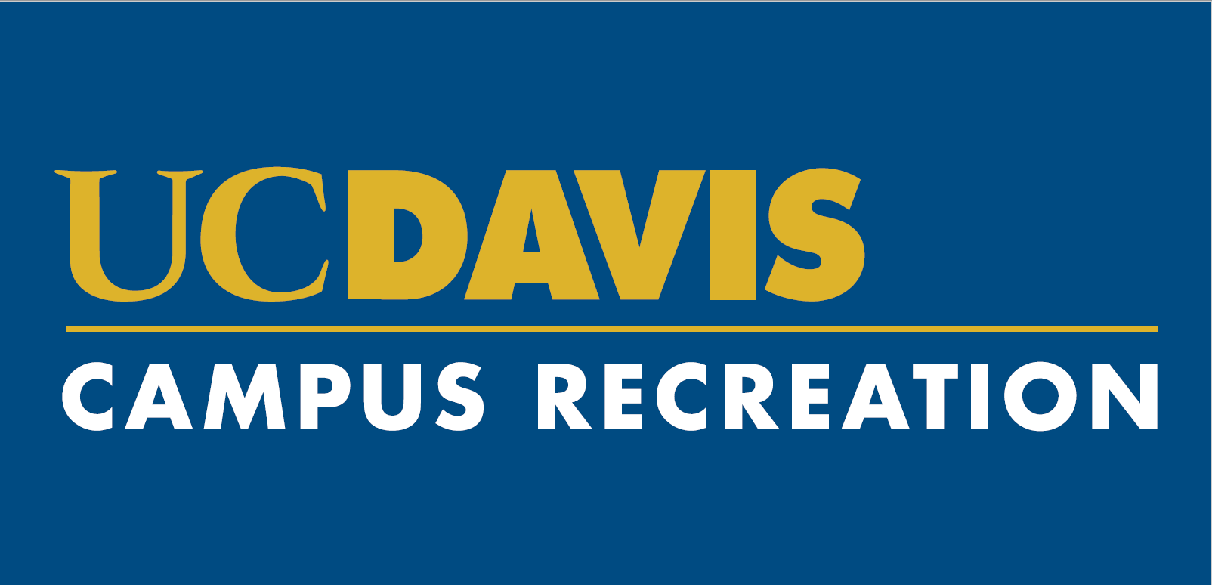
Recreation Advisory Council Application 2019-2020
Dear Prospective Council Member,
We are excited that you are interested in becoming an active member of the 2019-2020 Recreation Advisory Council. Serving on a board or a committee at UC Davis is not only a great way to give back to the campus Community, but is also an opportunity to exercise your professional development. It is our goal to find students, staff, faculty and graduate students in and outside of Campus Recreation.
Over the course of your role on the Council, you will learn about how budgets are determined and how they affect day-to-day operations. A focal point will be to learn how projects are started and carried out at the administrative level, and the issues that arise between the interactions of various competing interests. You will get a head start in the working world by understanding how a large-scale organization functions. The benefit of this knowledge is tremendous. Not only will you get to see behind the scenes, but you will also learn the tools to improve this campus.
In addition, this council will serve as our core outreach team at various events throughout the year. The team will receive training on the depth and breadth of the department and will be able to articulate our core values and mission. This dynamic group will provide an invaluable service in assisting, planning and working various events out in the UC Davis community.
On the Recreation Advisory Council, we have spent the last year discussing and advising on Campus Recreation’s facility openings with the ARC and Rec Pool, the collaboration between ICA and the EQC, policies and rates as well as items like should we keep scales in the bathrooms. We came together to work the Stride for Aggie Pride 5k and discussed the current climate around the band and how best we could support the active students who are navigating how to support their peers. It was important to us to think about ways to engage the 20-30% of the student population not utilizing our programs and services and other exciting topics.
Beyond your experience in Campus Recreation with your willingness to learn the issues and represent your fellow students, we do not ask that you possess any special knowledge or training to apply for the Council. Moreover, that is the best part of this opportunity – your desire to be a more engaged student is all we are looking for.

Sincerely,

Recreation Advisory Council

Recreation Advisory Council Application 2019-2020

Thank you for your interest in participating in the Recreation Advisory Council (RAC). Please answer the questions below and include your class schedule including any other commitments you have outside of school.

- What are your interests, goals and ideas related to the Recreation Advisory Council?

- Please list any prior committee service or related experience.

- Applications are sought from students representing the broad range of diversity that exists at UC Davis. If you wish, please provide any information that would assist us in that goal. (Optional)

- Please share why you want to be a member of the Recreation Advisory Council.

- How will you bring student opinions beyond your own to the council?

Please provide the following information:

Name
Year In School
Email
Phone
Anticipated Graduation Date
Preferred method of communication (phone, email, text, etc.)

